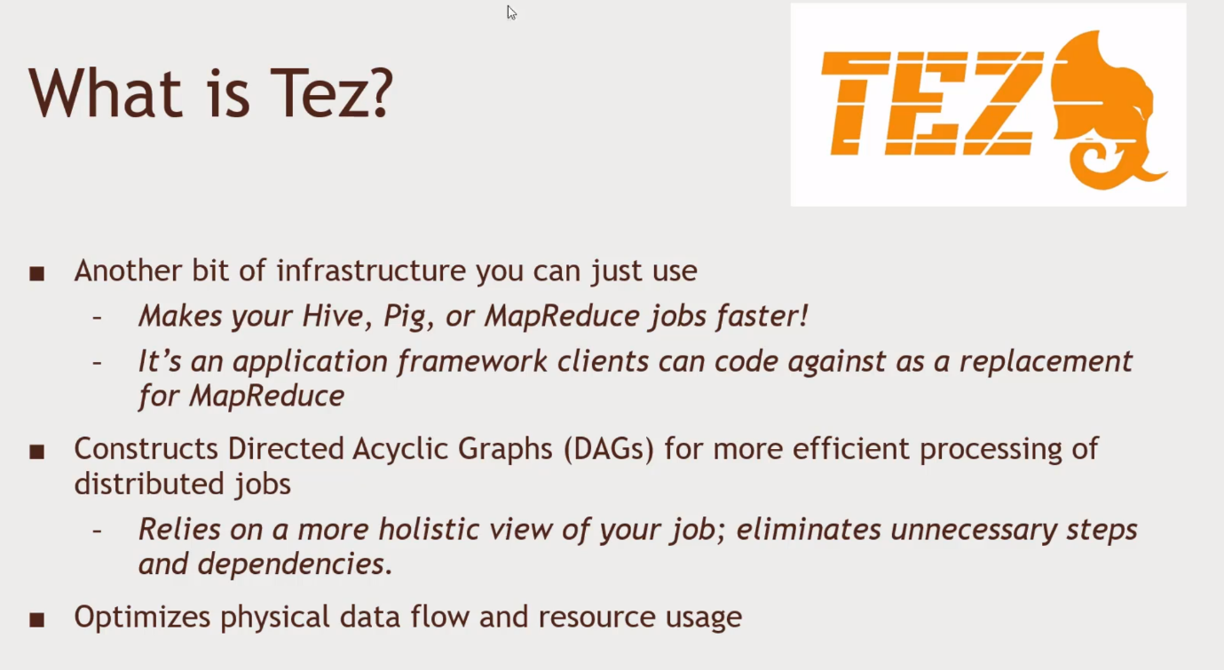Accelerating your job while running Hadoop.

Directed Acyclic Graphs

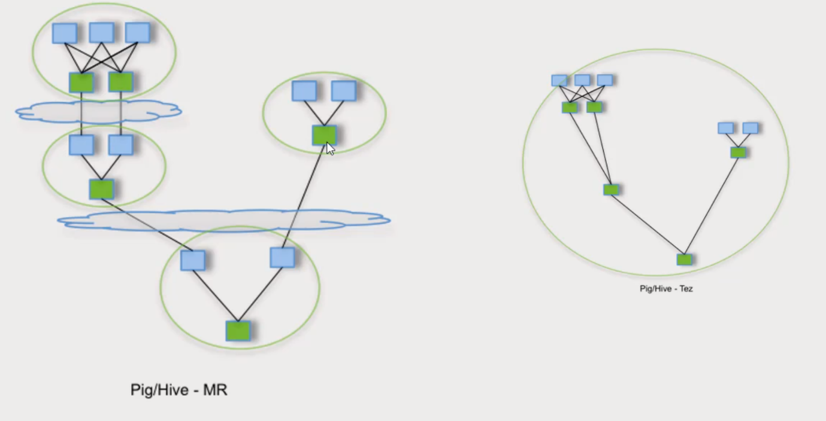

HDFS

Map Reduce Jobs

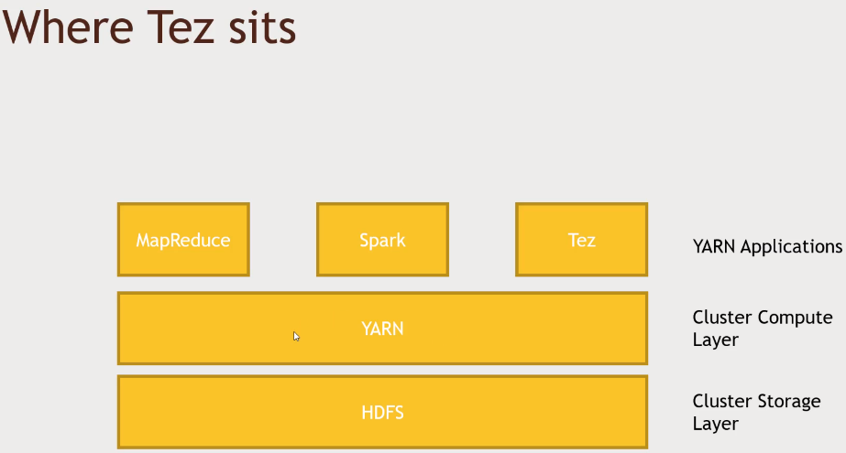

Using Hive on Tez

1. Login to Ambari as maria_dev
2. Go to Hive View
   1. Ensure you have MovieLens and MovieName databases
   2. Type in the SQL query in the Query Editor.
   3. Click on the gear icon,
   4. Add hive.execution.engine, then tez
3. Run the SQL query and time the results fetching. 20 seconds to finish under tez.
4. See if you get the same timing when you use map reduce.
   1. Click on gear icon and click on mr.
   2. It takes 1 minute and 11 seconds
5. Click on Tez view, and see the most recent jobs and etc.